**Agent and Counsellor Performance**

Segment 1: Agents with the Best Performance

Overview:

We began by analyzing the performance of our agents, focusing on two critical metrics:

1. The number of leads each agent handled.
2. The rate at which these leads were converted into active tokens.

Key Findings:

* Top Agents by Number of Leads:
  + Fahim Moshin Khan, Ayush Dixit, and Saket Rai emerged as the top-performing agents in terms of the sheer number of leads they handled. Their ability to manage a high volume of leads reflects their efficiency and effectiveness in the initial stages of the sales funnel.
* Top Agents by Conversion Rate:
  + Saket Rai and Chitwan Soni demonstrated an outstanding 100% conversion rate. Every lead they worked with successfully turned into an active token, showcasing their exceptional skill in converting prospects into paying customers.

Key Insight: The performance of agents like Saket Rai and Chitwan Soni highlights the importance of quality over quantity. By studying and replicating their methods, we can potentially improve the overall conversion rates of the entire team. These agents are demonstrating the effectiveness of their approach, and their methods could serve as a benchmark for training other agents.

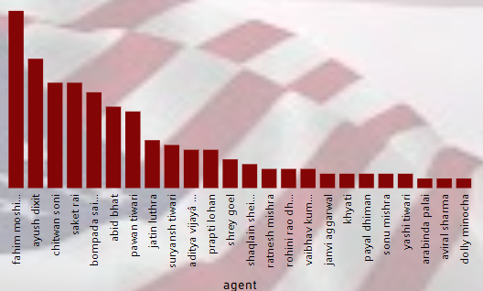 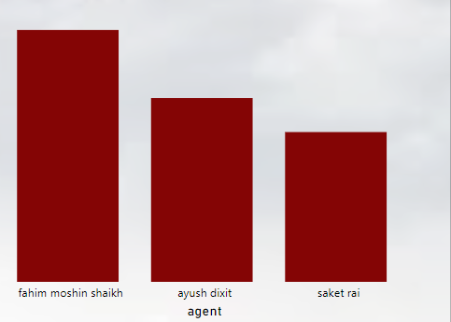

Segment 2: Counsellors with the Best Performance

Overview:

The performance of our counsellors was analyzed by reviewing the number of leads they managed and their success in converting these leads into paying customers.

Key Findings:

* Top Counsellors by Number of Leads:
  + Shilendra Singh, Diptikantajena, and Aviral Sharma were identified as the counsellors handling the most leads. These individuals have played a pivotal role in moving prospects through the latter stages of the sales funnel.
* Top Counsellors by Conversion Rate:
  + Aviral Sharma and Rishabh Tripathi have both achieved a 100% conversion rate, meaning every lead they handled became a successful sale. Their expertise in closing deals is evident and critical to the company’s success.

Key Insight: Top-performing counsellors like Aviral Sharma and Rishabh Tripathi are vital assets. Their ability to consistently convert leads into paying customers is a model that the entire team can benefit from. Sharing their techniques and best practices with other counsellors could elevate the overall performance of the department.

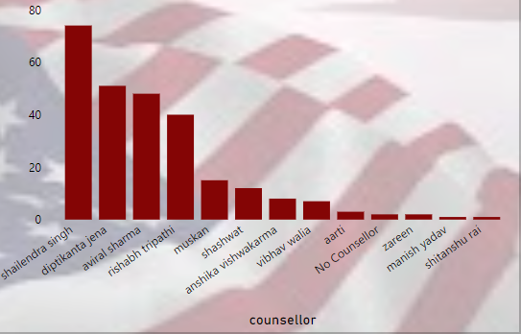 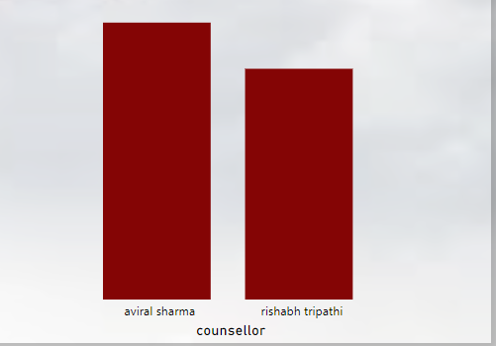

Segment 3: Best Agent-Counsellor Duo

Overview:

The success of our agent and counsellor pairings was also reviewed to identify the most effective teams working together to move leads through the sales pipeline.

Key Findings:

* Top Agent-Counsellor Duo:
  + The partnership between Fahim Moshin Shaikh and Shilendra Singh has emerged as the highest-performing duo, driving a significant number of successful conversions. Their ability to work together effectively demonstrates the importance of synergy in achieving high conversion rates.
* Other Notable Pair:
  + The combination of Chitwan Soni and Aviral Sharma has also proven to be an outstanding team. Their collaboration has consistently resulted in successful outcomes, making them another top-performing duo within the organization.

Key Insight: These successful duos highlight the impact of collaboration in driving conversions. By identifying complementary skills between agents and counsellors, we can create more effective pairings and, in turn, enhance overall performance. Fostering such high-performing teams should be a focus moving forward.

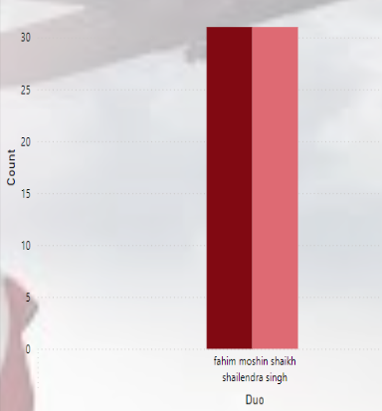

Conclusion and Recommendations:

Conclusion: The insights gained from analyzing our agents and counsellors have revealed the significant impact that both individual performance and collaboration have on driving successful conversions. Top agents like Saket Rai and Chitwan Soni, as well as top counsellors like Aviral Sharma and Rishabh Tripathi, are setting a high standard for success. Additionally, strong agent-counsellor pairings like Fahim Moshin Shaikh and Shilendra Singh are demonstrating the power of teamwork in achieving optimal results.

Recommendations:

1. Replicate Successful Methods:
   * Encourage agents and counsellors like Saket Rai, Chitwan Soni, Aviral Sharma, and Rishabh Tripathi to share their successful strategies with their peers. This knowledge-sharing could help improve the overall performance of other agents and counsellors.
2. Foster Strong Pairings:
   * Focus on continuing and expanding the collaboration between high-performing duos like Fahim Moshin Shaikh and Shilendra Singh, as well as Chitwan Soni and Aviral Sharma. By identifying similar complementary skills across the team, we can build more high-performing pairs.
3. Monitor and Adjust:
   * Continuously monitor the performance of agents, counsellors, and their pairings to ensure that successful methods are being replicated and optimized. Adjust training and pairing strategies as necessary to maintain high conversion rates and overall success.

